

FULLERTON HEALTHCARE AUSTRALIA

Functional Specification Documentation

Interface to SAP

Revision History

Ver. # | Date | Prepared By | Significant Changes | Reviewed By
1.0 | 18/6/2015 | Boorla Srinivas | Initial Document

Table of Content

INTERGRATION MECHANISM 3
OVERVIEW 3
DATA EXCHANGE FORMAT 3
FILE NAMING CONVENTION 3
FILE GENERATION SCHEDULE - DAILY 4
FILE DELIVERY 4
1. CSN (iCarus System) INTERFACE 4

INTERGRATION MECHANISM

OVERVIEW

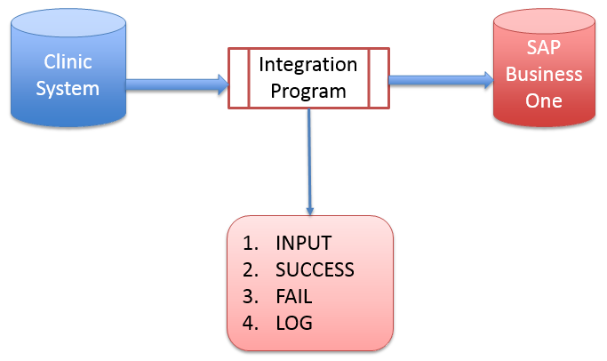

- Integration process is one way (Clinics to SAP B1)
- Integration program runs via batch automatically
- There are 4 folders need to be created on Virtual Machine server
- INPUT - This folder will keep the original file from Clinic and POS System (csv file) before imported to SAP Business One system. Mode of transfer form source (Info care ) folder to input (SAP) folder is via batch job execution.
- SUCCESS - This folder consists of all successful imported files.
- FAIL - This folder consists of all fail imported files.
- LOG – This folder consists of Debug & error log files.

DATA EXCHANGE FORMAT

Data Exchange Format | CSV (Text File)
Filed Separator | [ , ] (comma)
Field Delimiter | [ “ ] (double quote)

FILE NAMING CONVENTION

Fullerton Allied Health Pty Ltd (FAH)  Front Desk system  A/R Invoice File Naming | FAH_AR_yyyymmdd_hhnn.txt
Medicheck Australia Pty Ltd (MED)  Best Practice  A/R Invoice File Naming  Incoming Payment File Naming | MED_AR_yyyymmdd_hhnn.txt  MED_RC_yyyymmdd_hhnn.txt
Jobfit Health Group Pty Ltd (JHG)  Health monitoring system  A/R Invoice File Naming | JHG_AR_yyyymmdd_hhnn.txt
Corporate Services Network Pty Ltd (CSN)  iCarus  A/R Invoice File Naming | CSN_AR_yyyymmdd_hhnn.txt

FILE GENERATION SCHEDULE - DAILY

File generation schedule – Daily Interface | 9:00 PM every day

FILE DELIVERY

Options | FTP, Copy to folder

CSN (iCarus System) INTERFACE

This Interface will extract the data from CSN in .CSV file and Integrates with SAP Business one.
A/R Invoice document will be created in SAP B1. Below are the mapping details.

Column Name | SAP Filed Name | Type | Remarks
Invoice Number | U_AI_RefDocNum | NVARCHAR | iCarus Invoice Number
Item No | INV1.Itemcode/description | NVARCAHR | if services is with item code (if not applicable leave it blank)
GL Code | INV1.AcctCode | NVARCHAR | GL revenue code
Additional Information | INV1.Text |  | line memo or description of service invoice
Quantity | INV1.qty | INT | default to 1
GST Amount | INV1.taxamount | NUMERIC | GST amount of Invoice
Total | INV1.LineTotal | NUMERIC | invoice amount including GST
Sent On | OINV.DocDate | DATE | Date of Invoice sent to Customer
Document Type | U_AI_BenefitType | NVARCHAR | type of Invoice services
Insurer | U_AI_INSURER | NVARCHAR | Insurer name
Customer Code | OINV.CardCode | NVARCHAR | Customer Code
Direct Invoicing | OINV.CardName | NVARCHAR | Customer Name
Others | U_AI_NATURE | NVARCHAR
Branch Code | INV1.ocrcode2 (auto populate inv1.ocrcode5) | NVARCHAR

